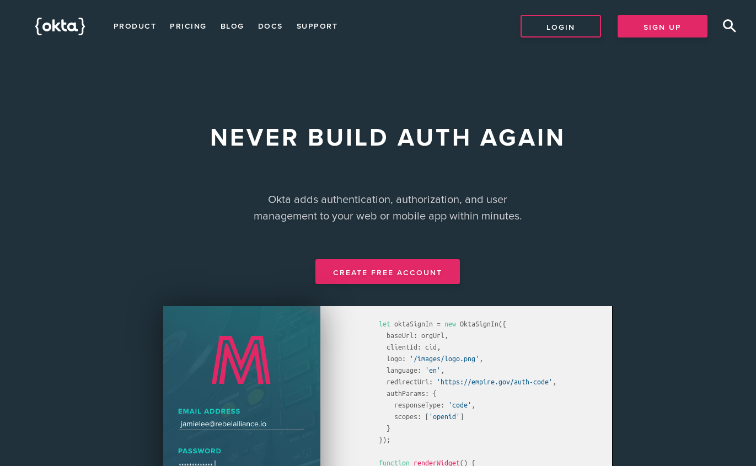

In your browser, navigate to [developer.okta.com](https://developer.okta.com/) and click on **Create Free Account** and enter your details.

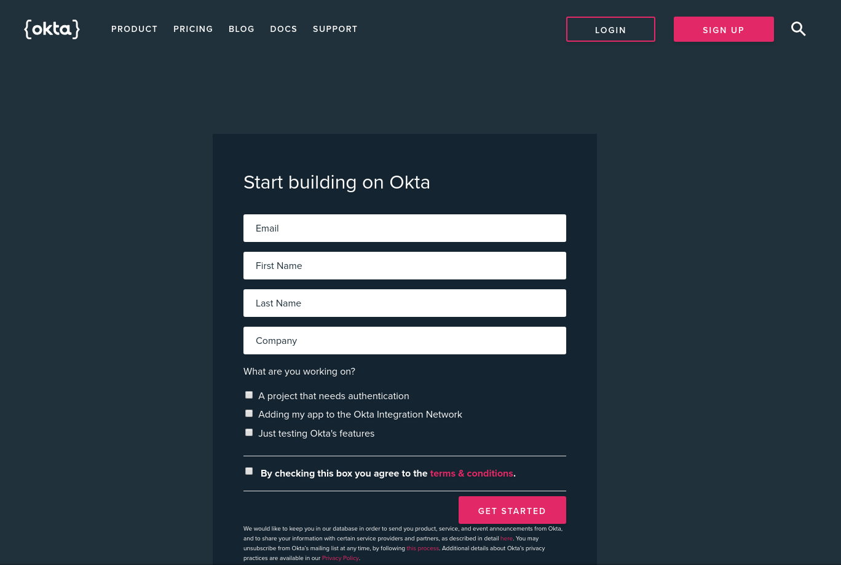

Once you are done you will be taken to your developer dashboard. Click on the **Add Application** button to create a new application.

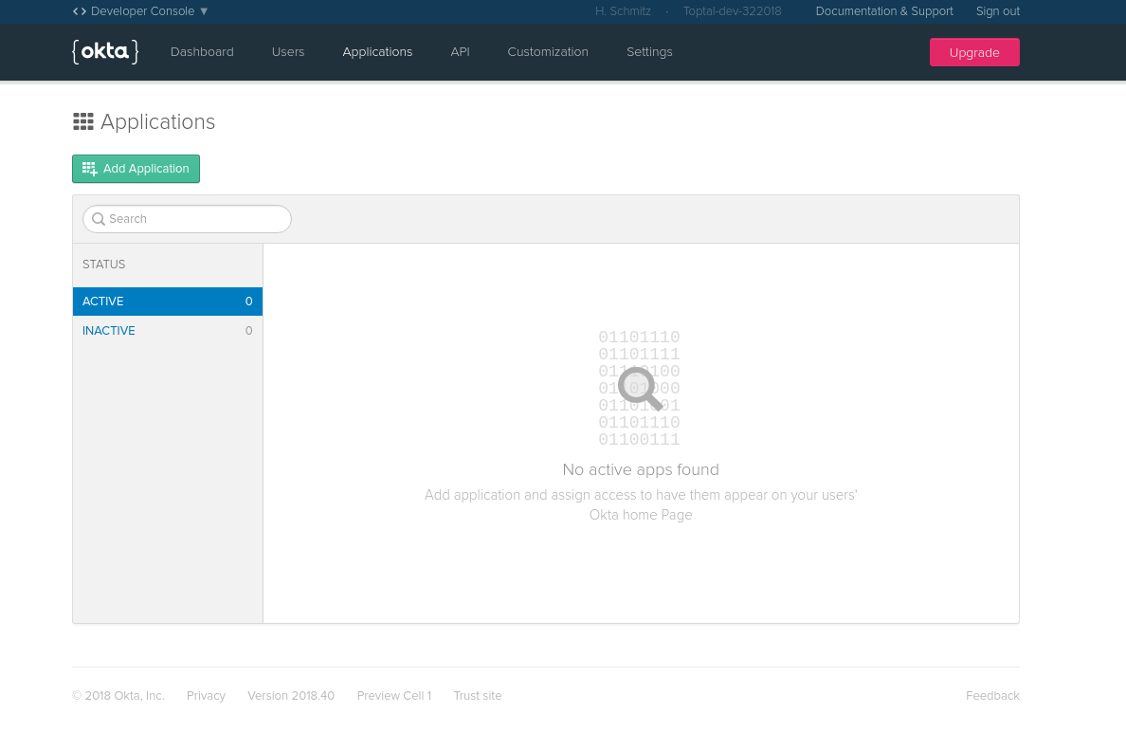

Start by creating a new single page application. Choose **Single Page App** and click **Next**.

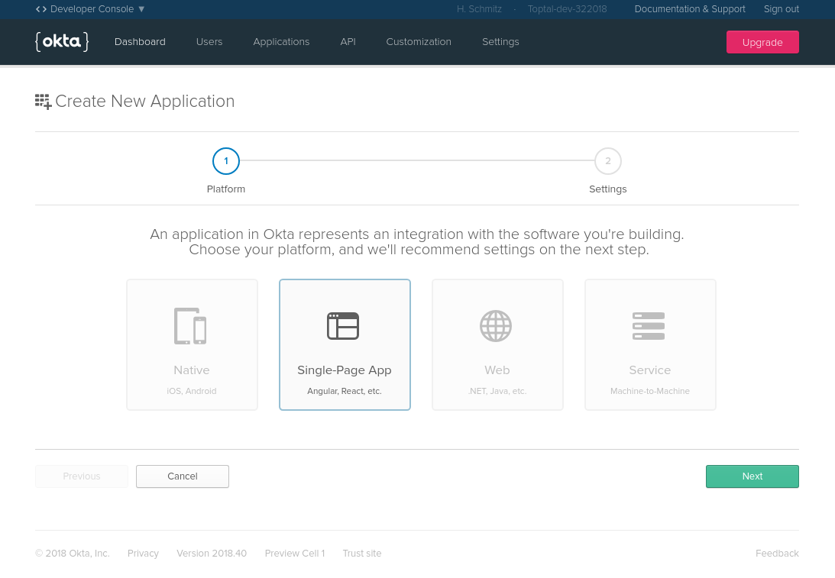

On the next page, you will need to edit the default settings. Make sure that the port number is 4200. This is the default port for Angular applications.

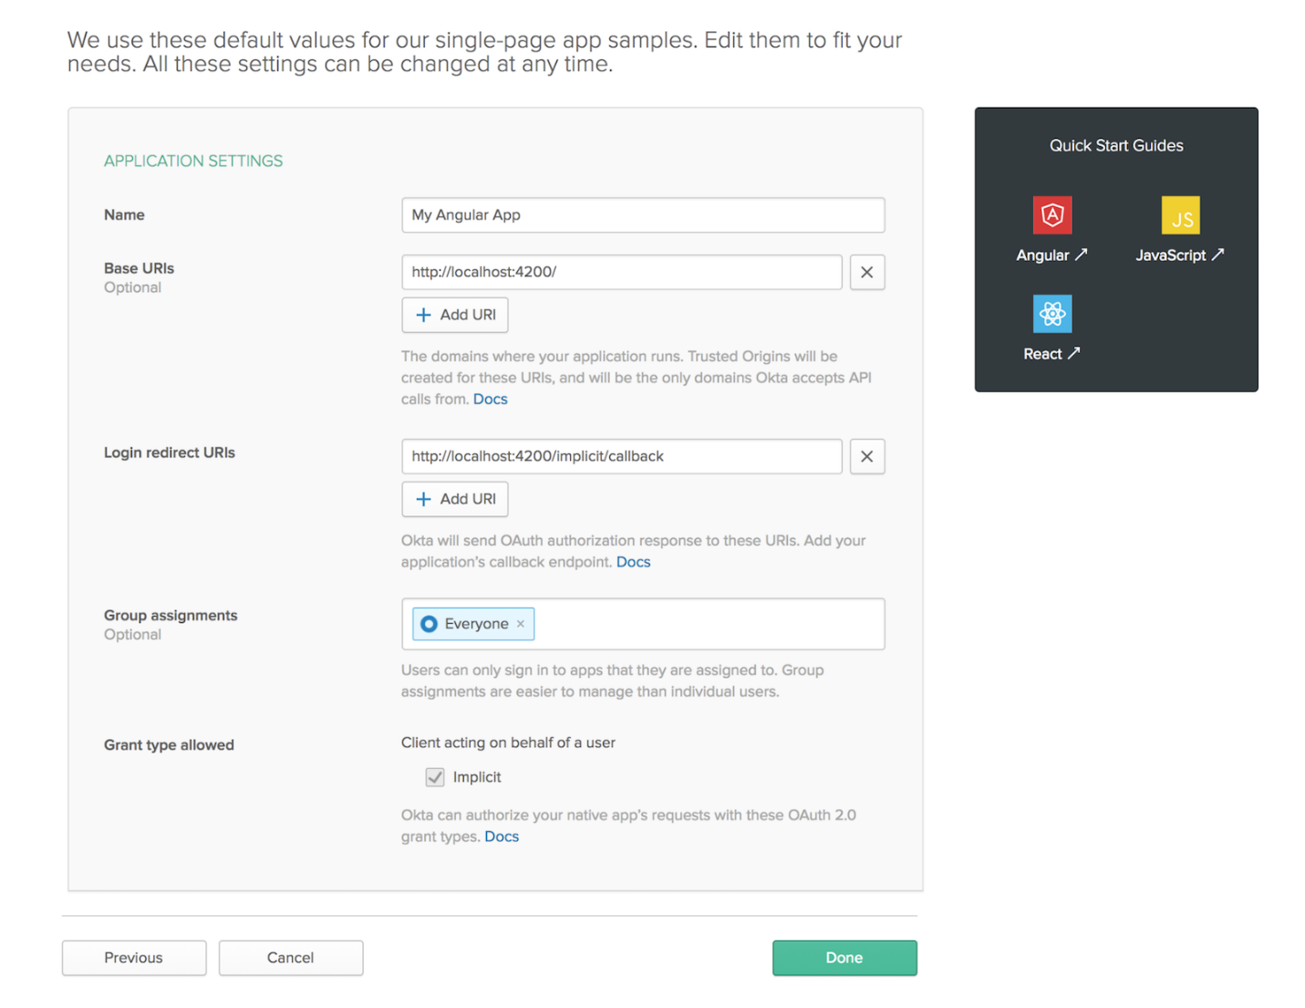

That’s it. You should now see a **Client ID** which you will need to paste into your TypeScript code.

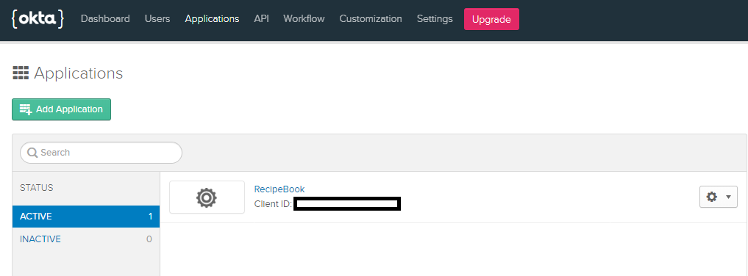

You also need the Organization URL. Go to Okta Home Page

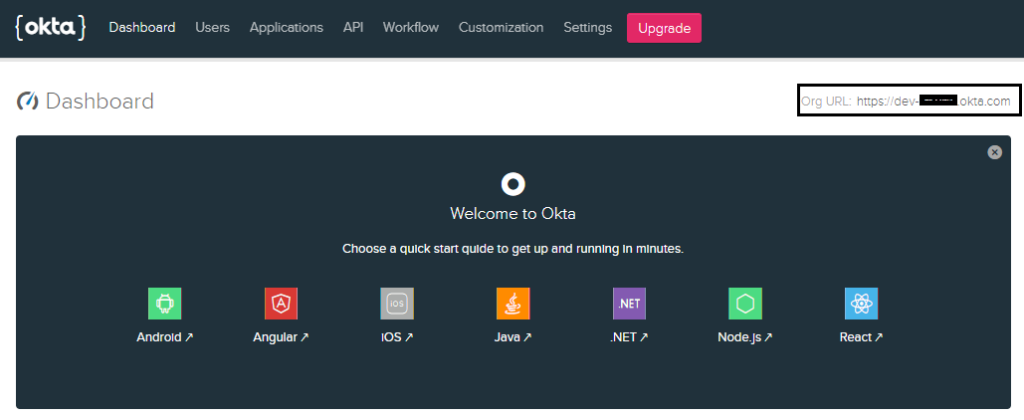

Once you have the ClientID and Org URL, copy and paste into each of the respective fields into the config files in RecipeBook and RecipeBookServer.

RecipeBook – located at “{Your PC path}\recipebook\RecipeBook\config\config.json”

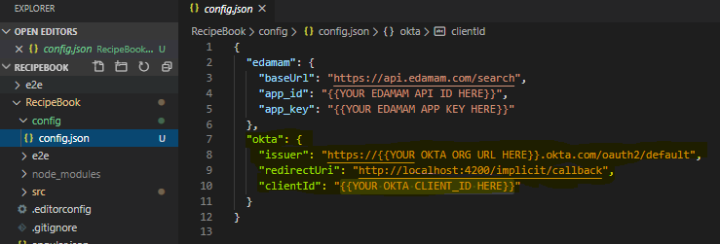

RecipeBookServer – located at “{Your PC path}\recipebook\RecipeBookServer\config\default.json”

